**Parametric Equations Notes/Worksheet**

Graphing a Plane Curve Described by Parametric Equations

1. Select some values of $t$ on the given interval
2. For each value of $t$, use the given parametric equations to find $x$ and $y$
3. Plot the points $(x,y)$ and connect them with a smooth curve

***Example 1***

Graph the plane curve defined by the parametric equations: $x=t^{2}-2t+1$ and $y=3t$ for $-3≤t≤3$

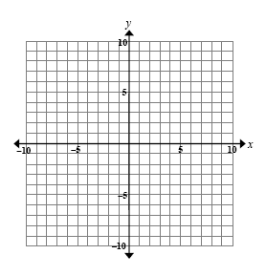

|  |  |  |  |
| --- | --- | --- | --- |
| $$t$$ | $$x=t^{2}-2t+1$$ | $$y=3t$$ | $$(x,y)$$ |
| -3 |  |  |  |
| -2 |  |  |  |
| -1 |  |  |  |
| 0 |  |  |  |
| 1 |  |  |  |
| 2 |  |  |  |
| 3 |  |  |  |

Sometimes we want to ‘eliminate the parameter’ and obtain the rectangular equation.

1. Begin with the parametric equations.
2. Solve for in one of the equations.
3. Substitute the expression for $t$ in the other parametric equation.

***Example 2***

Eliminate the parameter for the equations and give the rectangular equation for $x=t^{2}-2t+1$ and $y=3t$

***Homework 1***

Graph the parametric equations $x=1-2t$ and $y=2-t$ for $-∞<t<∞$

Eliminate the parameter of the equations above and give the resulting rectangular equation.

Sometimes we want to obtain parametric equations from the rectangular equation. A set of parametric equations for the plane curve defined by $y=f(x)$ is $x=$ and $y=$. When doing so, be sure that the domain does not change.

***Example 3***

For the parabola whose equation is $y=16-x^{2},$ which parametric equations for $x$ works?

$x=t$ $x=t+1$ $x=\sqrt{t}$ $x=t^{2}$

Find a set of parametric equations for the equation $y=16-x^{2}$

***Homework 2***

Find a set of parametric equations for the equation

$$y=\frac{6x^{2}-3}{x}$$

Graph the parametric equations then eliminate the parameter. Be careful of the domain.

***Homework 3 $x=3t+2$ $y=\sqrt{t+4}$***

*****Homework 4 $x=t+2$ $y=\frac{4}{t}$***